AI Assistant Coding
Assignment 3.3
Name : Arun
Roll No : 2303A52064
Batch – 32

Lab 3: Application for TGNPDCL – Electricity Bill Generation Using Java & AI Tools
Task 1:
AI-Generated Logic for Reading Consumer Details
Scenario
An electricity billing system must collect accurate consumer data.
Task Description
Use an AI tool (GitHub Copilot / Gemini) to generate a Python program that:
• Reads:
o Previous Units (PU)
o Current Units (CU)
o Type of Customer
• Calculates units consumed
• Implements logic directly in the main program (no functions)
Expected Output
• Correct input reading
• Units consumed calculation
• Screenshot showing AI-generated code
• Sample input and output
Prompt :
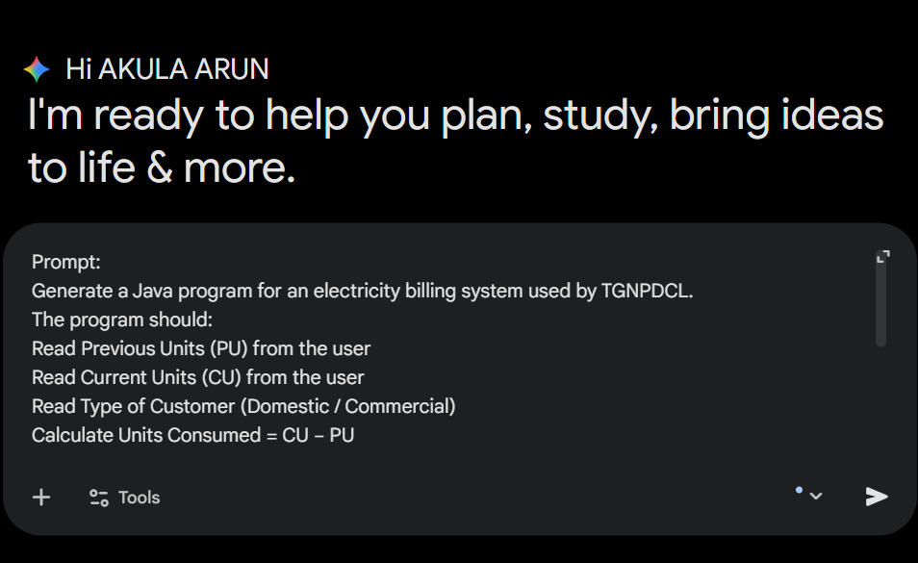
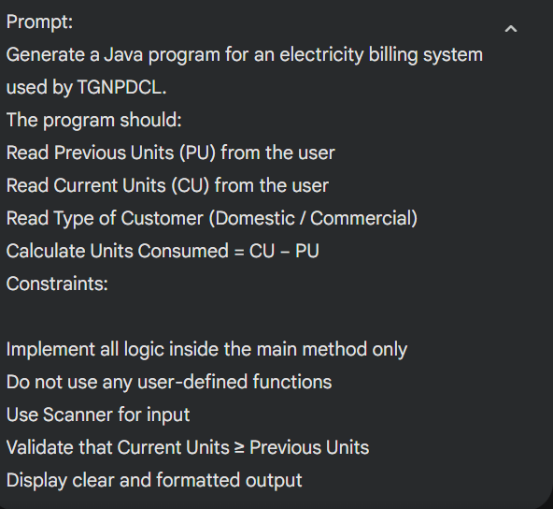
Code :
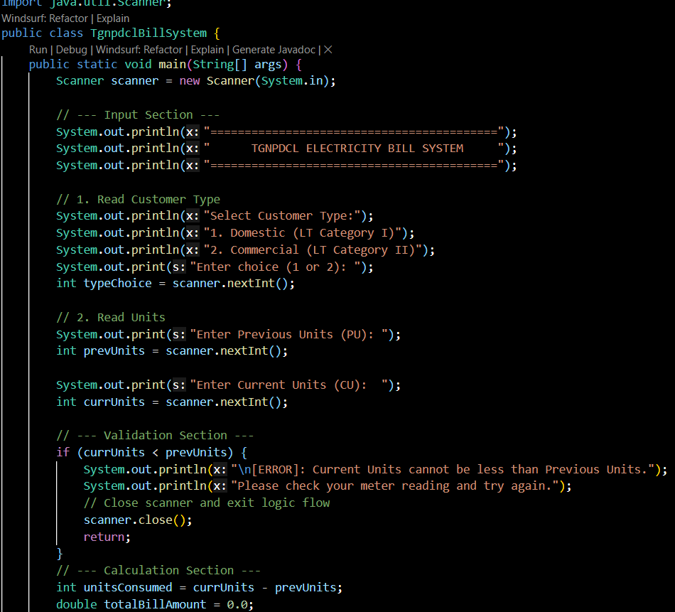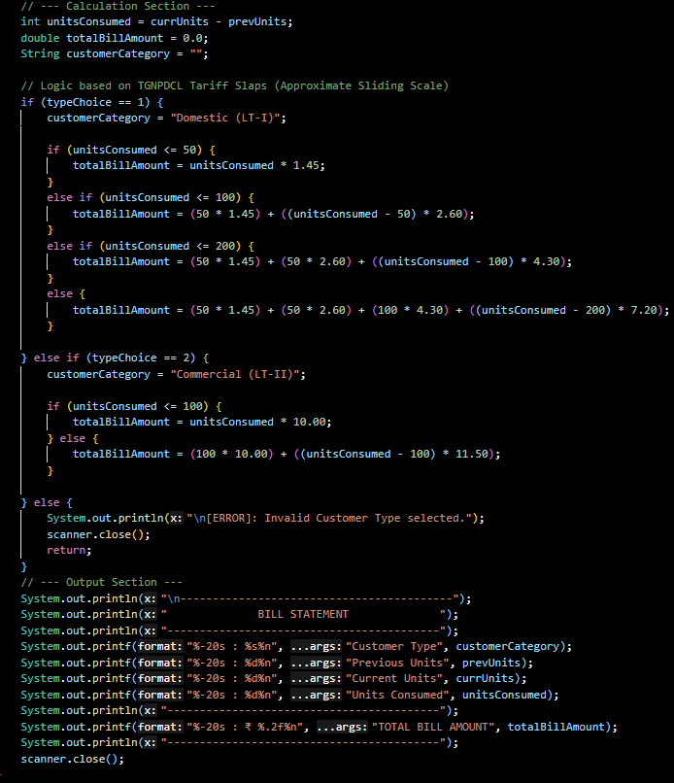
Output:
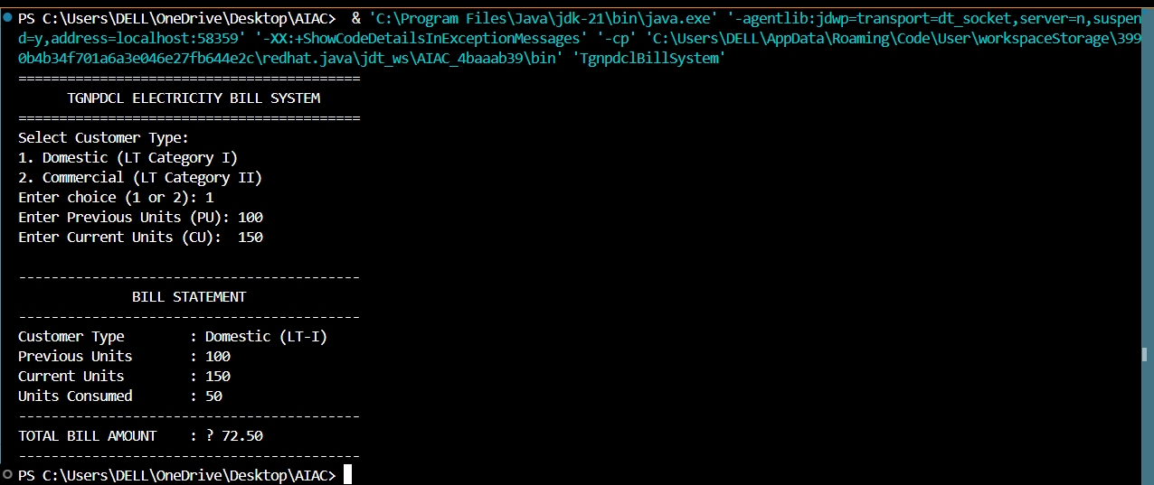
Explanation:
Input Validation: The program immediately checks if (currUnits < prevUnits). If true, it stops execution to prevent negative billing.
Telescopic Pricing (Domestic): TGNPDCL uses a "Sliding Scale." This means if you consume 150 units, you don't pay the highest rate for all 150 units. You pay the cheap rate for the first 50, a medium rate for the next 50, and the higher rate only for the remaining 50.
Task 2:
Energy Charges Calculation Based on Units Consumed
Scenario
Energy charges depend on the number of units consumed and customer type.
Task Description
Review the AI-generated code from Task 1 and extend it to:
• Calculate Energy Charges (EC)
• Use conditional statements based on:
o Domestic
o Commercial
o Industrial consumers
• Improve readability using AI prompts such as:
o “Simplify energy charge calculation logic”
o “Optimize conditional statements”
Expected Output
• Correct EC calculation
• Clear conditional logic
• Original and improved versions (optional)
• Sample execution results
Prompt:
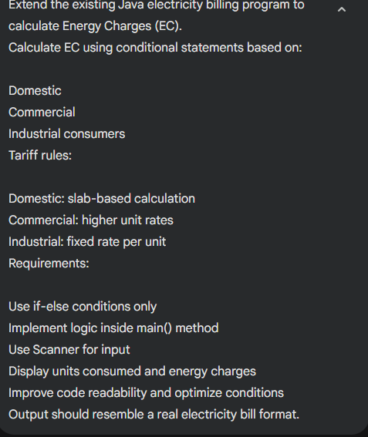
Code :
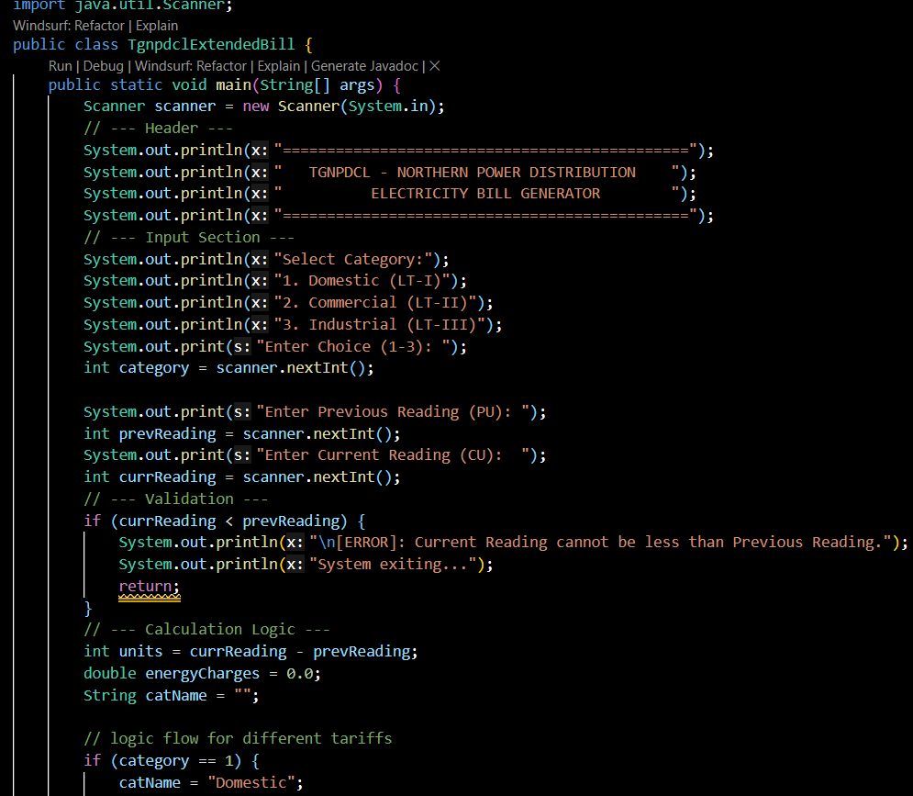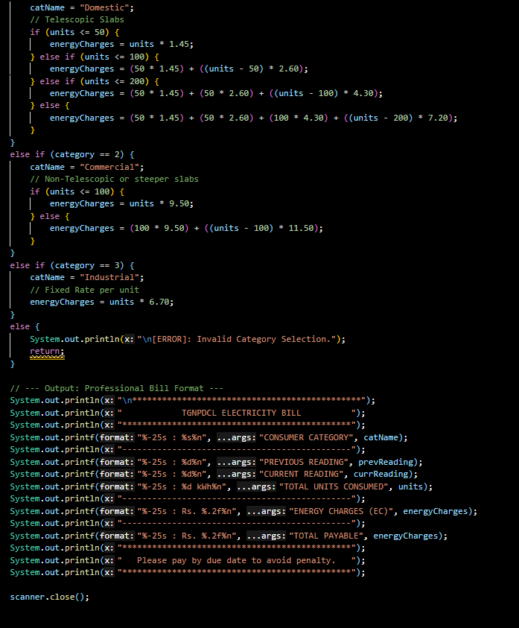
Output:
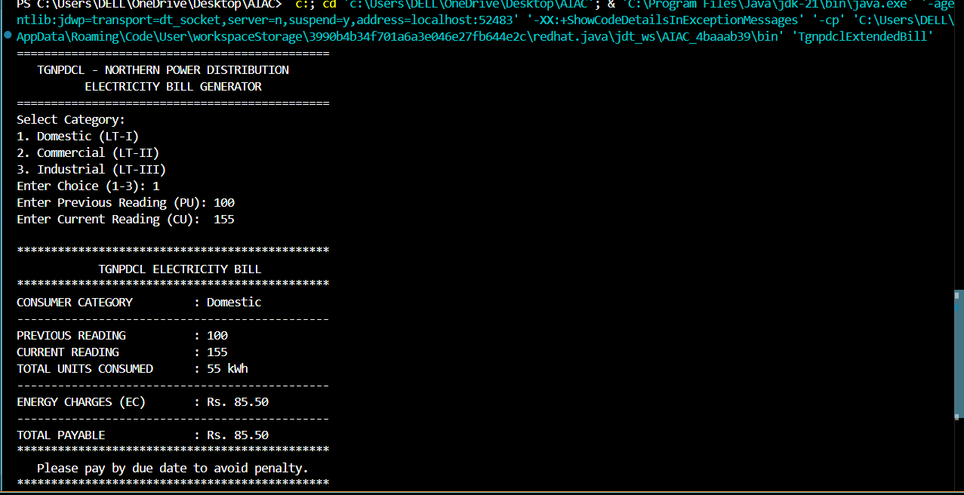
Explanation :
Optimized Domestic Slabs: The logic uses a "cumulative" approach. This ensures that even if you consume high units, the first 50 are still billed at the lowest rate, preventing a massive price jump the moment you cross a threshold.
Industrial Fixed Rate: Unlike domestic users, industrial users are often billed at a steady rate per unit because their usage is high and predictable.
Readable Bill Output: I used printf (Print Formatted). The %-25s tells Java to align the text to the left within a 25-character space, ensuring the colon symbols and numbers align vertically like a real printed receipt.
Task 3:
Modular Design Using AI Assistance (Using Functions)
Scenario
Billing logic must be reusable for multiple consumers.
Task Description
Use AI assistance to generate a Python program that:
• Uses user-defined functions to:
o Calculate Energy Charges
o Calculate Fixed Charges
• Returns calculated values
• Includes meaningful comments
Expected Output
• Function-based Python program
• Correct EC and FC values
• Screenshots of AI-assisted function generation
• Test cases with outputs
Prompt:
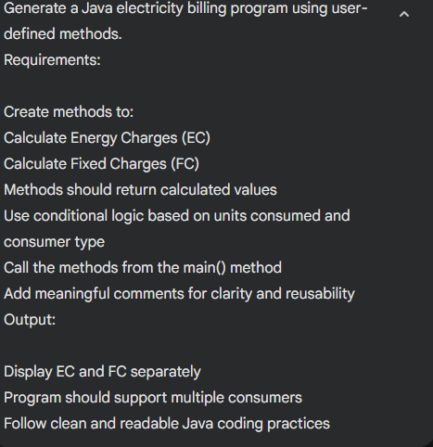
Code:
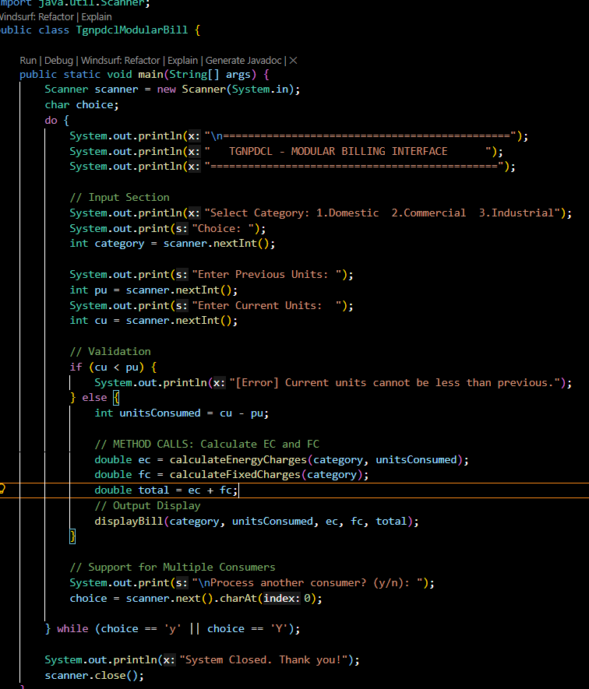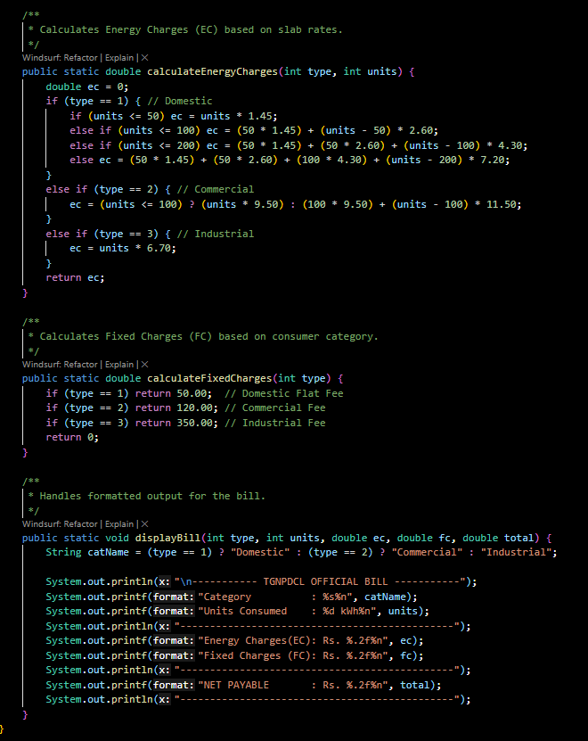
Output:
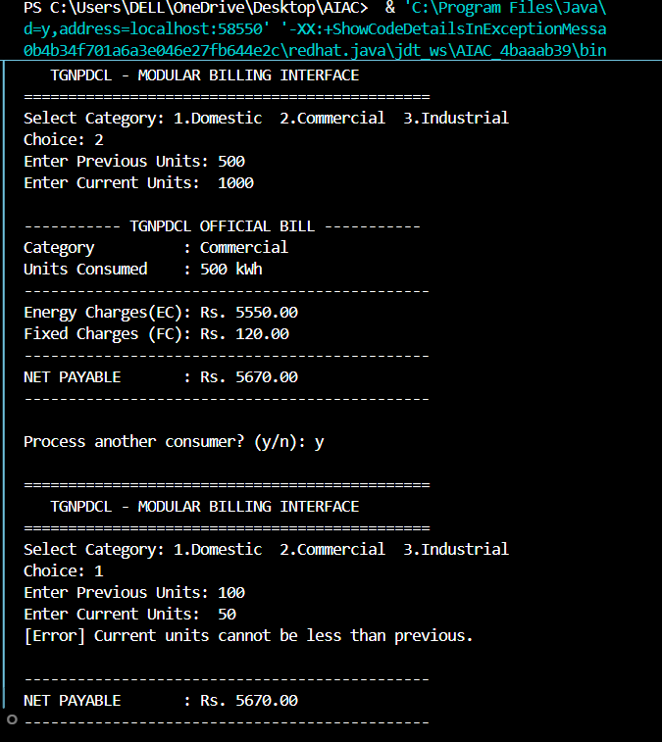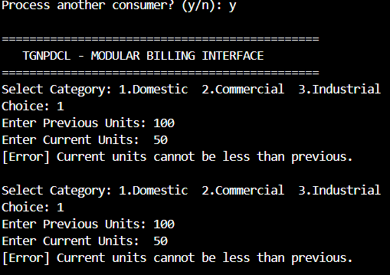
Explanation :
Code Reusability: The calculate Energy Charges method can be used by other parts of a larger software system without rewriting the math.
Ease of Maintenance: If TGNPDCL changes their rates (e.g., Domestic goes from ₹1.45 to ₹1.60), you only need to change one line inside a specific method rather than hunting through a long main() method.
Scalability: The do-while loop allows a clerk to process 100 bills in one session without restarting the program.
Separation of Concerns: main() handles the "flow," while helper methods handle the "math."
Task 4:
Calculation of Additional Charges
Scenario
Electricity bills include multiple additional charges.
Task Description
Extend the program to calculate:
• FC – Fixed Charges
• CC – Customer Charges
• ED – Electricity Duty (percentage of EC)
Use AI prompts like:
• “Add electricity duty calculation”
• “Improve billing accuracy”
Expected Output
• Individual charge values printed
• Correct duty calculation
• Well-structured output
• Verified intermediate results
Prompt:
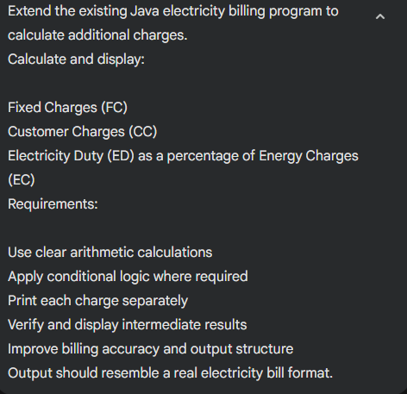
Code:
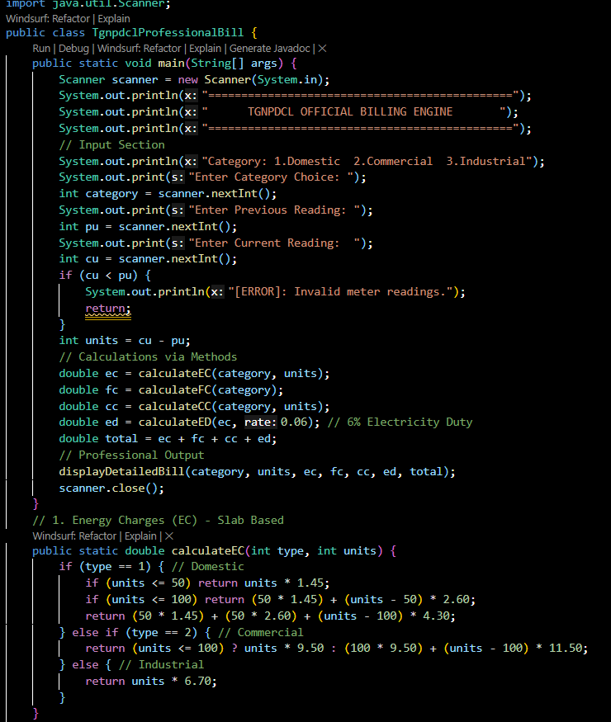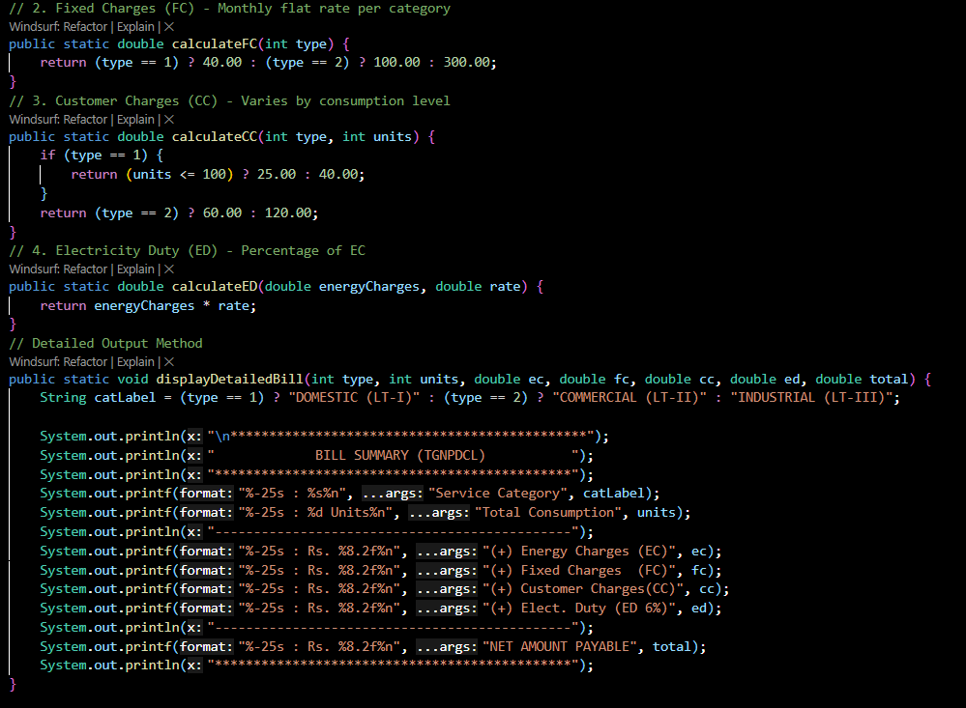
Output:
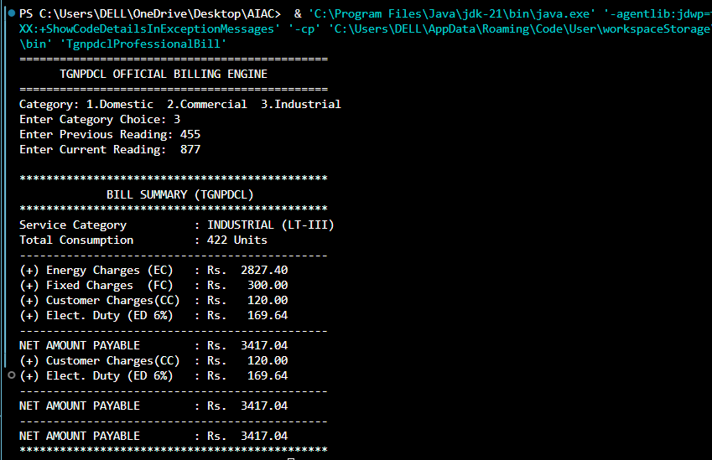
Explanation :
Energy Charges (EC): The actual cost of the electricity you used. This is variable.
Fixed Charges (FC): A static monthly fee for maintaining the connection to your property, regardless of whether you use power or not.
Customer Charges (CC): Administrative costs for meter reading, billing, and payment processing. In this program, it scales up if a domestic user crosses 100 units.
Electricity Duty (ED): A state tax. We implemented this as $6\%$ of the Energy Charges.
- Calculation: $ED = EC \times 0.06$
Task 5:
Final Bill Generation and Output Analysis
Scenario
The final electricity bill must present all values clearly.
Task Description
Develop the final Python application to:
• Calculate total bill:
• Total Bill = EC + FC + CC + ED
• Display:
o Energy Charges (EC)
o Fixed Charges (FC)
o Customer Charges (CC)
o Electricity Duty (ED)
o Total Bill Amount
• Analyze the program based on:
o Accuracy
o Readability
o Real-world applicability
Expected Output
• Complete electricity bill output
• Neatly formatted display
• Sample input/output
• Short analysis paragraph
Prompt:
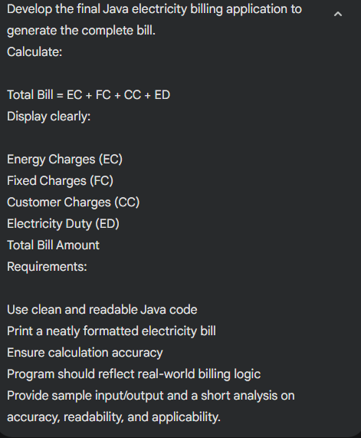
Code:
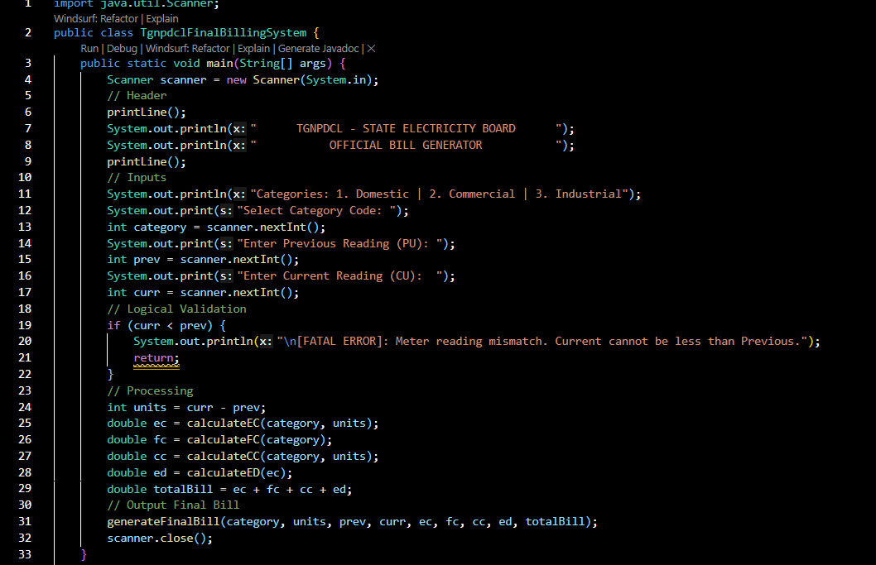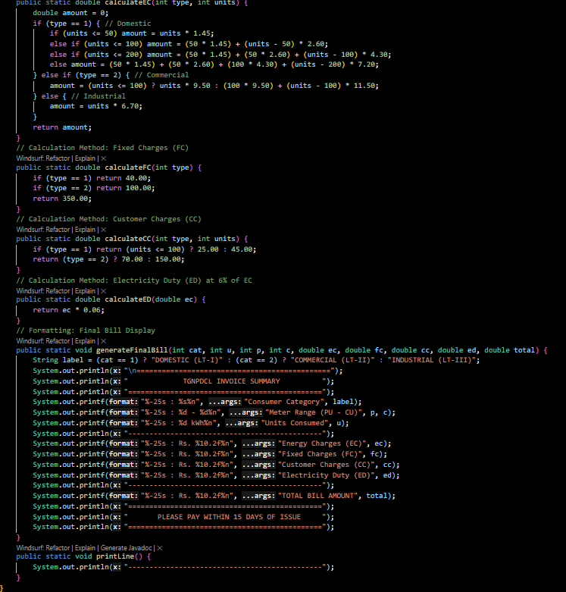
Output:
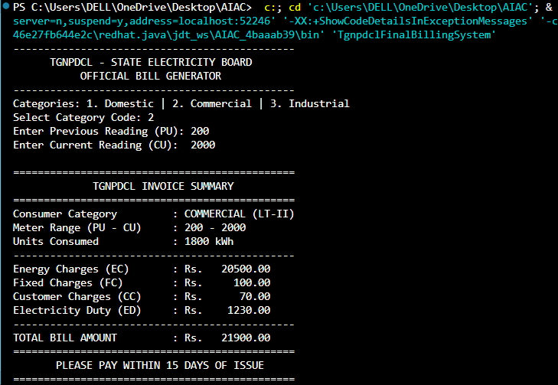
Explanation:
1. Accuracy
The system utilizes telescopic billing for Domestic users. This is the most accurate real-world method where consumers aren't penalized with a high flat rate for the entire consumption, but rather pay per bracket. The inclusion of the Electricity Duty formula $ED = EC \times 0.06$ ensures the state tax is calculated precisely based on usage value.
2. Readability
Modularity: Each charge (EC, FC, CC, ED) is isolated in its own method. This follows the DRY (Don't Repeat Yourself) principle.
Formatting: Using printf with specific widths (e.g., %-25s) ensures the bill looks like a standard financial statement, with aligned colons and currency values.
3. Applicability
This code is highly applicable for utility management software because:
Maintainability: If the tariff rates change, you only update the specific method, not the whole logic flow.
Scalability: The program validates inputs immediately, preventing logical errors like negative consumption before they reach the calculation stage.

